Northwind Traders Company

**Contents**

* Summary
* Introduction
* Data Overview
* Data Preparation and Cleaning
* Data Analysis and Visualisation
* Key Insights and Recommendation
* Conclusion

**1. Summary**

Northwind Traders is considering expanding its business. To make informed decisions, the management requires a detailed analysis of the current sales data, including products, employees, suppliers, customers, and inventory. This case study provides insights derived from the data analysis using Power BI.

**Key Insights:**

* Overview of sales performance.
* Identification of top-selling products and categories.
* Analysis of employee performance.
* Supplier and customer distribution insights.

**2. Introduction**

Northwind Traders is a retail company dealing in various products. Understanding the current sales trends is crucial for their strategic planning and expansion efforts.

The objective of this analysis is to provide actionable insights into the company's sales data to support decision-making regarding expansion.

**3. Data Overview**

**Data Sources:**

* **Employees:** Details of employees working for Northwind Traders.
* **Customers:** Details of customers who buy from Northwind Traders.
* **Orders:** Details of sales transactions.
* **Order Details:** Detailed invoices for each order.
* **Products:** Information about the products.
* **Categories:** Categories to which products belong.
* **Suppliers:** Suppliers providing products.
* **Shippers:** Details of shippers delivering products.

**Data Relationships:** The tables are interconnected, with keys such as EmployeeID, CustomerID, OrderID, ProductID, and SupplierID linking the datasets.

**4. Data Preparation and Cleaning**

**Steps Taken:**

* Imported data into Power BI.
* Handled null values by removing rows with missing data.
* Handled null values by replacing the values.
* Merged necessary columns to create comprehensive fields (e.g., FirstName and LastName into FullName).
* Established relationships between tables to ensure data integrity.

**5. Data Analysis and Visualization**

**Key Dashboards Created:**

1. Sales Analysis Dashboard
2. Employee Performance Dashboard
3. Supplier Analysis Dashboard
4. Customer Demographics Dashboard

**1.** Sales Analysis Dashboard

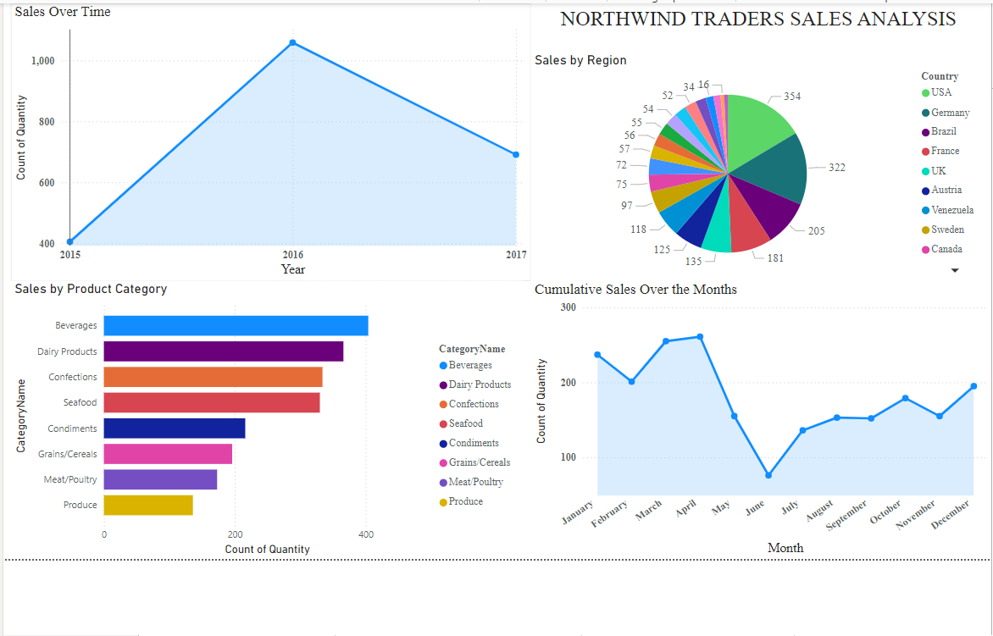

**2.** Employee Performance Dashboard

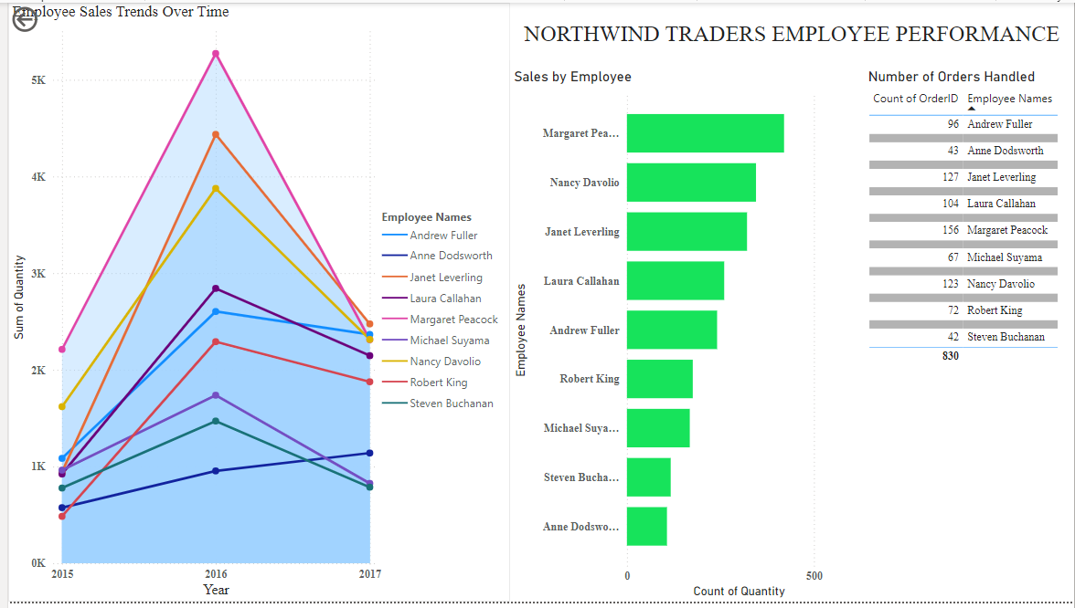

**3.** Supplier Analysis Dashboard

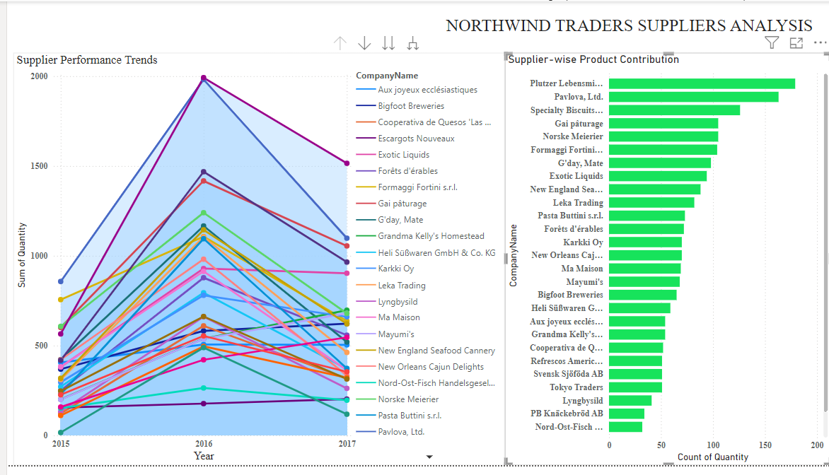

**4.** Customer Demographics Dashboard

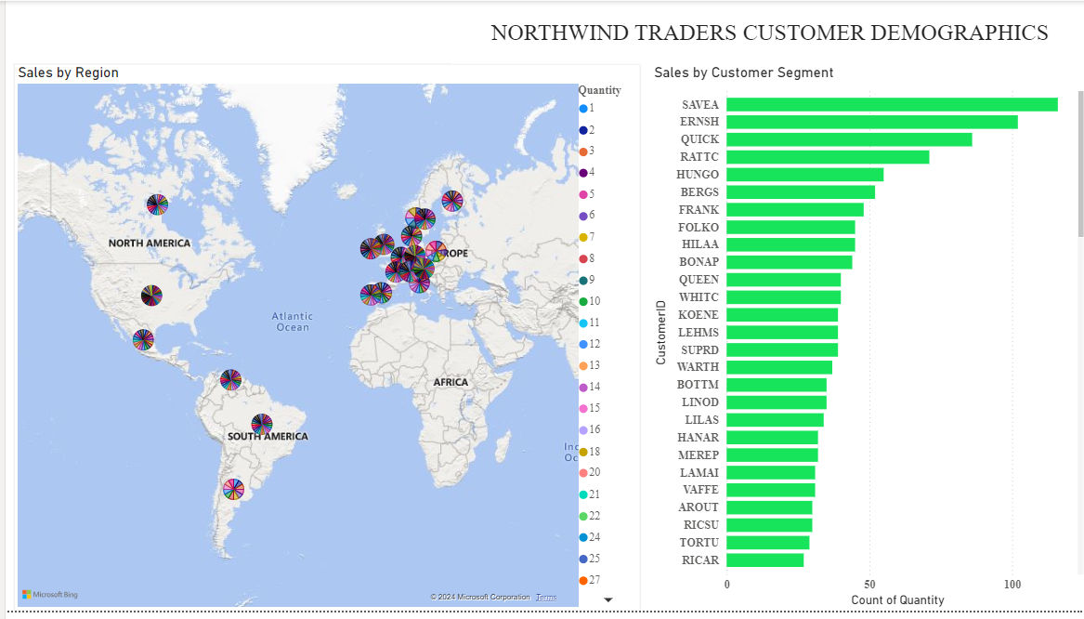

**6. Key Insights and Recommendations**

**Key Insights:**

1. **Sales Analysis:**
   * Top-selling products and categories identified.
   * Seasonal trends observed in product sales.
2. **Employee Performance:**
   * Variation in sales performance among employees.
   * Identification of top-performing employees.
3. **Supplier Analysis:**
   * Key suppliers contributing to high sales.
   * Efficiency of suppliers in product delivery.
4. **Customer Demographics:**
   * Sales distribution across different regions.
   * Identification of key customer segments.

**Recommendations:**

1. **Focus on High-Performing Products:**
   * Increase inventory and marketing for top-selling products.
2. **Enhance Employee Training:**
   * Provide training to underperforming employees to boost sales.
3. **Strengthen Supplier Relationships:**
   * Collaborate more closely with high-performing suppliers.
4. **Target High-Sales Regions:**
   * Expand operations in regions showing high sales potential.

**7. Conclusion**

This sales analysis provides a comprehensive overview of Northwind Traders' current sales landscape. The insights derived from this analysis will aid the management in making data-driven decisions to support the company's expansion plans and improve overall business performance.